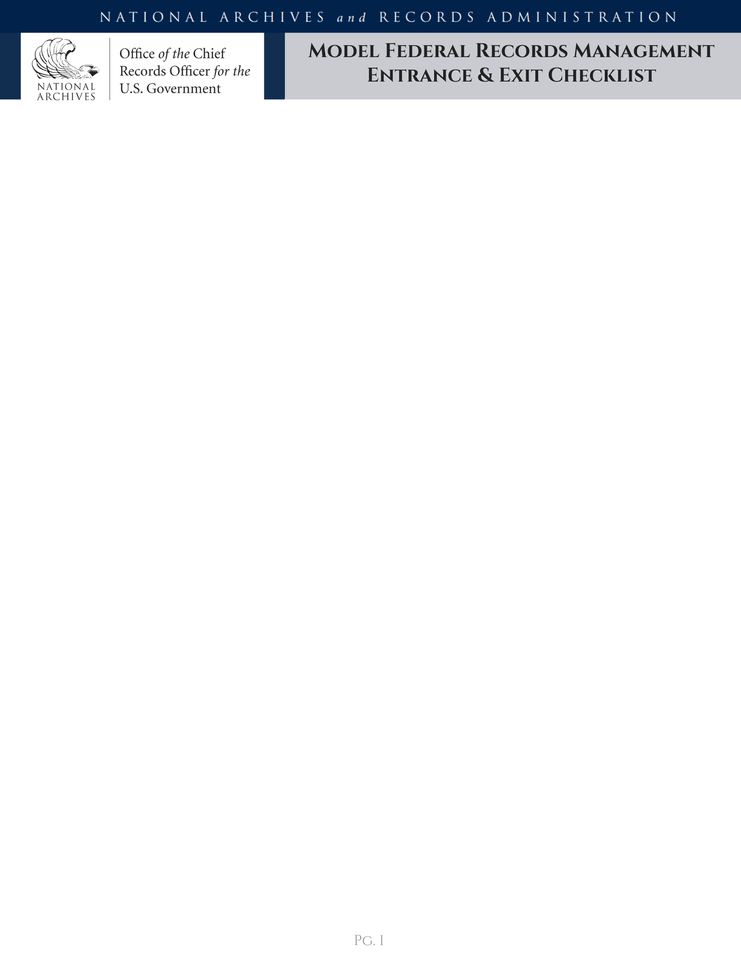
Model Entrance Checklist
NARA developed the following model checklists for agency records management staff to adapt for their agency’s needs as part of entrance and exit briefings or training. These checklists describe basic records management responsibilities and tasks all individuals should complete when entering or leaving federal service. The acknowledgement column is for individuals to complete after receiving onboarding records management briefings/training and to complete prior to leaving the agency. For more information about federal records management go to:
https://www.archives.gov/records-mgmt/transition/records-management-guidance-federal-employees

Statement | Acknowledge
- I completed the agency records management training.
- I understand the work products and communications I create in the performance of my duties are federal records.
- I understand the difference between federal records and personal materials.
- I understand the records I create or receive belong to my agency and the federal government and are not my personal property.
- I understand I have the responsibility to create and capture records that adequately and properly document my work, duties, and responsibilities.
- I understand I have a responsibility to protect the records created by my agency, including preventing their loss or unauthorized destruction and protecting information from unauthorized public release.
- I have been briefed on my agency and work unit’s instructions on where to save records in agency systems, shared drives, document management platforms, and files.
- I know I should not maintain personal materials on federal systems to the greatest extent possible and that any personal materials stored on agency systems should be separated and easily identifiable.
Model Entrance Checklist Contd.
Statement | Acknowledge
- I know I should use agency-provided systems and tools to conduct agency business.
- I understand I am required to cc or forward all federal electronic messages created or received in personal accounts, including those on non-agency provided mobile devices, to my official account within 20 days.
- I understand when and how to properly dispose the types of records under my responsibility according to my agency’s policies and practices.
- I understand I am required to report actual, impending, or threatened unlawful removal, defacing, alteration, corruption, deletion, erasure, or other destruction of Federal records in my custody.
- I know who to contact with questions about managing my work unit’s records and information.
EMPLOYEE NAME / SIGNATURE / DATE
I acknowledge that I briefed the Employee on our office's recordkeeping instructions and the Employee's records management responsibilities listed above.
SUPERVISOR NAME / SIGNATURE / DATE
I acknowledge that the Employee completed agency records management training and that I provided Employee with training materials informing the Employee on Employee's records management responsibilities listed above.
RECORDS MANAGEMENT OFFICIAL NAME / SIGNATURE / DATE

Model Exit Checklist
Statement | Acknowledge
- I have completed an exit interview with my agency’s records management staff or designated official.
- I have ensured that all records under my responsibility are captured in official recordkeeping systems and are available to appropriate agency staff.
- I have ensured all password protected or encrypted accounts, systems, and files can be accessed by the appropriate agency staff.
- I have returned all paper or analog records checked out to me to the appropriate storage facility.
- I have complied with the requirement to cc or forward all federal electronic messages created or received in personal accounts, including those on non-agency provided mobile devices, to my official account.
- I have not removed any sensitive, personally identifiable, protected health, FOIA- restricted, or classified information.
- I have identified and preserved all records and information subject to litigation holds, preservation notices, claims, audits, inquiries, or other actions, and notified the appropriate staff of the location of the responsive records and information.
- I have confirmed an agency official has reviewed and approved all personal materials, non-records, and copies of records I plan to take with me

Model Exit Checklist CONTD.
Acknowledgement Statement: I understand that federal records may not be removed from government custody, nor may they be destroyed without a records schedule that has been approved by the Archivist of the United States. I understand that penalties may be enforced for the unlawful removal or destruction of records and that the maximum penalty for the willful and unlawful destruction, damage, or alienation of Federal records is three years in prison (18 USC 2071).

EMPLOYEE NAME / SIGNATURE / DATE
SUPERVISOR NAME / SIGNATURE / DATE
RECORDS MANAGEMENT OFFICIAL NAME / SIGNATURE / DATE

